**Q1. WACP to print the size and range of various data types.**

#include <stdio.h>

#include <math.h>

int range_of(int r){

int min, max, temp;

r*=8;

temp = pow(2,r-1);

min = -temp;

max = temp - 1;

printf("\n %d to %d", min, max);

return 0;

}

int main(){

int a = sizeof(int), b = sizeof(float), c = sizeof(double), d = sizeof(char);

printf ("The size of int is %d bytes", a);

range_of(a);

printf ("\nThe size of float is %d bytes", b);

range_of(b);

printf ("\nThe size of double is %d bytes", c);

range_of(c);

printf ("\nThe size of character is %d bytes", d);

range_of(d);

return 0;

}

**Output:**

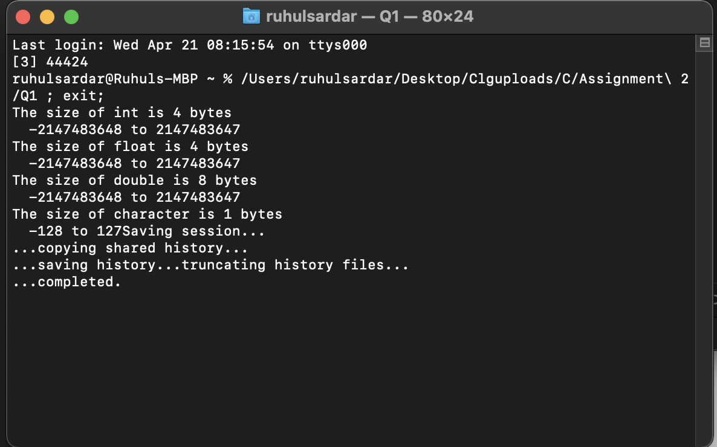

**Q2. WACP to calculate sum of digits of a five digit number without using loop construct.**

#include<stdio.h>

int main(){

int num, sum = 0, temp;

printf("Enter a five digit number: ");

scanf("%d", &num);

temp = num % 10;

sum += temp;

num = num / 10;

temp = num % 10;

sum += temp;

num = num / 10;

temp = num % 10;

sum += temp;

num = num / 10;

temp = num % 10;

sum += temp;

num = num / 10;

temp = num % 10;

sum += temp;

printf("\n\n\tThe sum is: %d ", sum);

return 0;

}

**Output:**

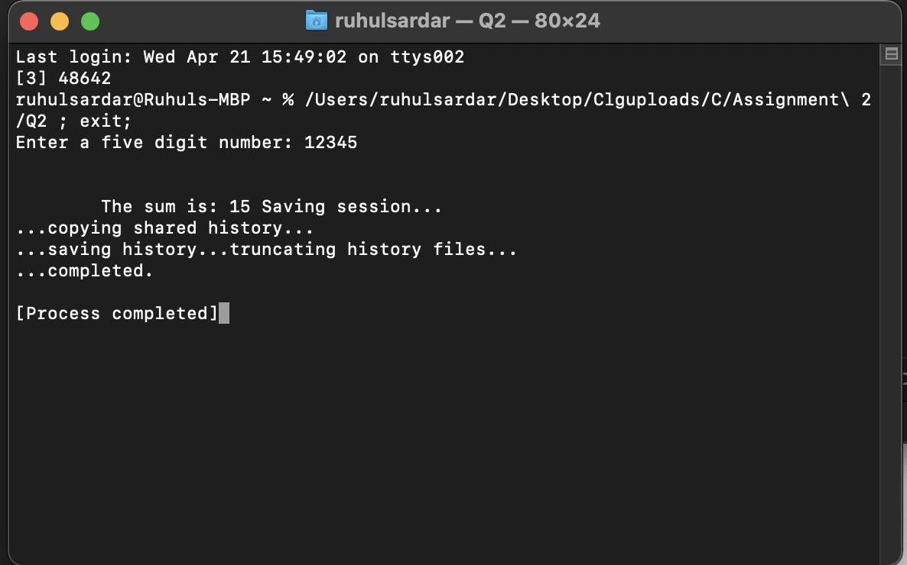

**Q3. WACP to find the average of five numbers.**

#include <stdio.h>

int main(){

int a, b, c, d, e, avg;

printf("\nEnter the 1st number: ");

scanf("%d", &a);

printf("\nEnter the 2nd number: ");

scanf("%d", &b);

printf("\nEnter the 3rd number: ");

scanf("%d", &c);

printf("\nEnter the 4th number: ");

scanf("%d", &d);

printf("\nEnter the 5th number: ");

scanf("%d", &e);

avg = (a + b + c + d + e)/5;

printf("The average is = %d", avg);

return 0;

}

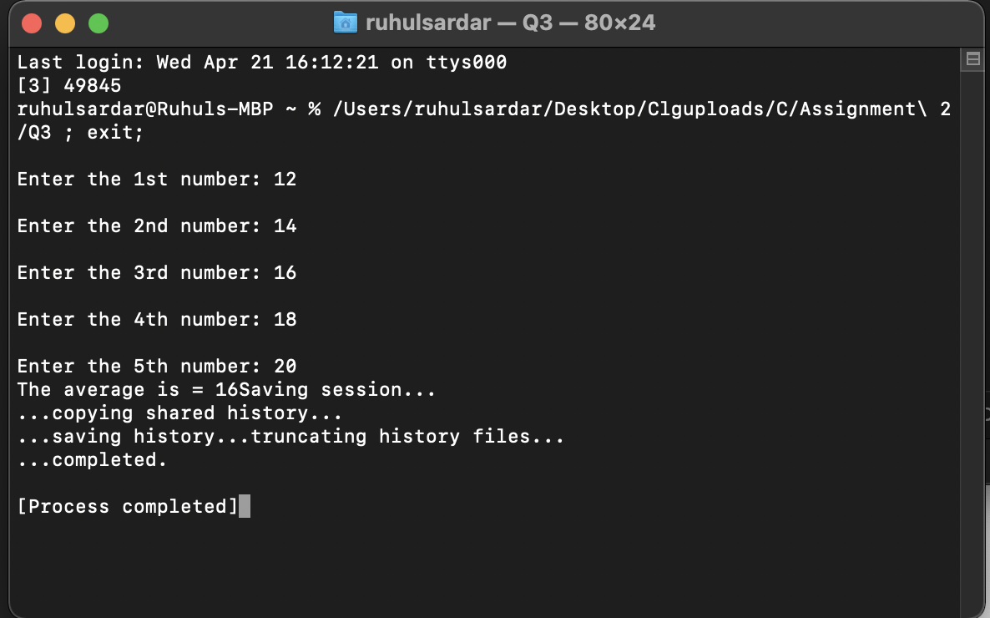**Output:**

**Q4. WACP to convert temperature in degree F to degree C and vice versa.**

#include <stdio.h>

int main()

{

float fh,cl;

int choice;

printf("\n1: Convert temperature from Fahrenheit to Celsius.");

printf("\n2: Convert temperature from Celsius to Fahrenheit.\n");

printf("\nEnter your choice (1, 2): ");

scanf("%d",&choice);

if(choice ==1){

printf("\nEnter temperature in Fahrenheit: ");

scanf("%f",&fh);

cl= (fh - 32) / 1.8;

printf("\nTemperature in Celsius: %.2f",cl);

}

else if(choice==2){

printf("\nEnter temperature in Celsius: ");

scanf("%f",&cl);

fh= (cl*1.8)+32;

printf("\nTemperature in Fahrenheit: %.2f",fh);

}

else{

printf("\nInvalid Choice !!!");

}

return 0;

}

**Output:**

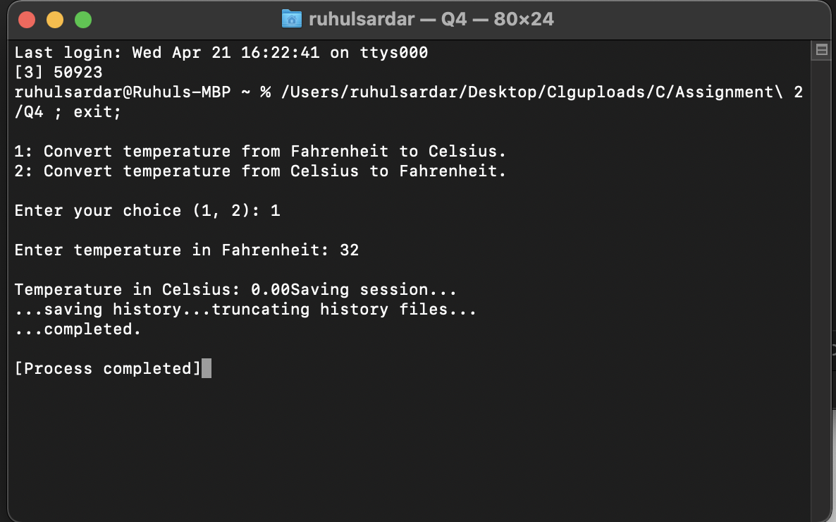

**Q5. WACP to read in the age of a person as an integer number in years and print the three immediate integral range of the age entered**.

#include <stdio.h>

int main(){

int age;

printf("Enter the age : ");

scanf("%d", &age);

printf("Three immediate integrals of %d are %d to %d , %d to %d and %d to %d", age, age-1, age+1, age-2, age+2, age-3, age+3);

return 0;

}

**Output:**

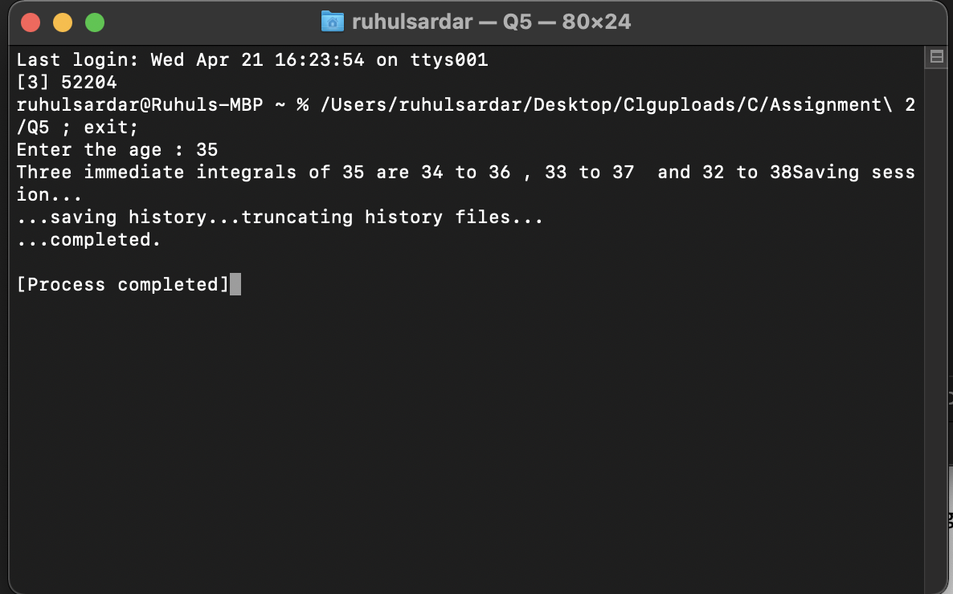

**Q6. WACP to swap 2 integer numbers using bit wise operators.**

#include<stdio.h>

int main(){

int a, b;

printf("Enter the value of a : ");

scanf("%d", &a);

printf("\nEnter the value of b : ");

scanf("%d", &b);

a = a ^ b;

b = a ^ b;

a = a ^ b;

printf("\n\nThe swapped value of a is %d", a);

printf("\n\nThe swapped value of a is %d", b);

return 0;

}

**Output:**

